   |  |   UNIVERSITY OF COLOMBO, SRI LANKA

UNIVERSITY OF COLOMBO SCHOOL OF COMPUTING
(Successor to the Institute of Computer Technology (ICT))

DEGREE OF BACHELOR OF INFORMATION TECHNOLOGY (EXTERNAL)

Academic Year 2003/2004 – 2nd Year Examination – Semester 3

IT3101: Object Oriented Systems Development

PART 2 – Structured Question Paper
28th February, 2004

(ONE AND HALF HOURS)

To be completed by the candidate

BIT Examination Index No:

Important Instructions:
- The duration of the paper is 1 1/2 (one and half) hours.
- The medium of instruction and questions is English.
- This paper has 4 questions and 12 pages.
- Answer question 1 and any 2 of the other questions only.
- All questions will carry equal marks.
- Write your answers in English using the space provided in this question paper.
- Do not tear off any part of this answer book.
- Under no circumstances may this book, used or unused, be removed from the Examination Hall by a candidate.
- Note that questions appear on both sides of the paper.
If a page is not printed, please inform the supervisor immediately.
- Non-programmable Calculators may be used.

Questions Answered
×
Indicate by a cross (×), (e.g. 1 ) the numbers of the questions answered.
 |  |  |  |  |  |  |  | Question numbers
 | To be completed by the candidate by  marking a cross (×). |  |  |  |  |  |  | 1 | 2 |  |  |  | 3 | 4
 | To be completed by the examiners:
 |  |  |  | Based on the following case study answer question 1.
1) |  |  |  | Video library  Case Study
Atlantic Video Library specializes in obscure videos. It lends videos only to members of the video society, which is part of an exclusive and very expensive Gentlemen’s club. Any member of the club automatically becomes a member of the video society. New members are admitted only on 1st January each year.

The library is set up along conventional lines, but there are no restrictions on the number of videos members may borrow at any one time. Videos have to be returned only if required by another member. Most of the active users of the library regularly change their videos. Two or three copies of popular titles are available.

In order to borrow a video, a member selects it, takes it to the issue desk and gives the video and his club membership card, to the librarian. The librarian takes the video ID card from the video sleeve and adds the membership number to the card. The librarian then places the card into the loan file and the member leaves with his video and his club membership card. This same procedure is followed in respect of each video borrowed.

When a member returns a video, he hands over the video to the librarian. The librarian finds the video card in the loans file and places the card in the video sleeve before returning the video to the library shelves not forgetting to remove the member number from the video card.

To reserve a video which is already on loan, the member gives the details of the video and the membership number to the librarian. The librarian finds the relevant video card in the loans file, and adds the member’s number to the reservation column on the video card. The librarian also makes a note of the member who has the video on loan and completes a return request card addressed to the member. The address is taken from the library copy of the club membership book. When the reserved video is returned, the librarian puts the video under the counter and completes a reservation ready card addressed to the member who requested the reservation. The member requiring the video can then pick the video up from the library and have it issued in the usual manner. Members make many inquiries from the librarian. Typical questions include- ‘”Is the video titled ‘abc’ on loan?”, “Which videos did actor ‘xyz’ appear in? “, “Have you got any videos on subject ‘def’?” and so forth. The librarian is able to answer these questions by inspecting the loan file, the actor index, the subject index and the title index.

In addition to the above duties, the librarian receives new videos from the social committee of the club. On receipt of a new video, the librarian has to make a video card for insertion in the video sleeve and then insert relevant entries for the indexes. The librarian is also responsible for amending the library copy of the membership book with changes of the addresses and at the end of the year , collecting the new membership book from the club secretary.

Note : The selection, ordering and payments for the videos are not considered relevant within the terms of the case study.

- Following is a Use Case diagram for the given system. Identify the Actors/Use Cases for labels A-F.
(30% Marks)

ANSWER IN THIS BOX
Librarian Returning
Prepare Reservation Ready Card Prepare Return Request Card

Inquiries Change Address
 |  |  |  |  | (A) |  |  |  |  |  | (B)
 |  |  |  |  | (C) |  |  |  |  |  | (D)
 |  |  |  |  | (E) |  |  |  |  |  | (F)
(b) Identify the potential Classes for the above system.
(30% Marks)

ANSWER IN THIS BOX
Member/Borrower
Borrowed Copy
Reserved Copy
Video Copy
Video Title
Subject
Actor
(c) Identify the static relationships between the above classes identified in (b). Indicate the cardinality of the appropriate relationships.
(25% Marks)
 |  |  |  |  | ANSWER IN THIS BOX
 |  |  |  |  | Class name  Reserved Copy  Video Copy  Video Title  Video Copy  Video Title  Video Title | Class name  Member  Borrowed Copy  Video Copy  Reserved Copy  Subject  Actor |  |  |  |  |  | Relationship and UML notation  Association 0..* 1  Inheritance  Composition  Inheritance  Association 1..* 1  Association 1..* 1..*
(d) Identify the object(s) responsible for the Use Case Reservation in (a).
(15% Marks)
 |  |  |  |  | ANSWER IN THIS BOX
Reserved Copy
Member

Video Copy
2) |  |  | - Given below are statements associated with Object Oriented concepts. You are required to match the statements in Column X with those in Column Y.
Column X | Column Y
(A) An Object | (i) is something that a class can do.
(B) Polymorphism | (ii) is a special type of relationship that exists if a class consists of a number of component classes.
(C) An operation; | (iii) specifies that an operation can have the same name in different classes, and each class will perform the operation in a specific way.
(D) An Aggregation | (iv) represents something in the real world.
 | (v) is the fundamental conceptual connection between classes.

(20% Marks)

ANSWER IN THIS BOX
iv

iii

i

ii
 |  |  |  |  | Column X (A) and Column Y ( )
 |  |  |  |  | Column X (B) and Column Y ( )
 |  |  |  |  | Column X (C) and Column Y ( )
 |  |  |  |  | Column X (D) and Column Y ( )
 |  | (b) What would be the output of the following program?
 |  | #include <iostream.h>  class A{  public :  A() {cout<<”In Constructor A ”;}  ~A(){cout<<”In Destructor A\n ”;}  };  class B {  public :  B(){cout<<”In Constructor B ”;}  ~B(){cout<<”In Destructor B\n ”;}  }; |  |  |  |  |  |  |  | class C : public A, public B{  public:  C(){cout<<”In Constructor C \n”;}  ~C(){cout<<”In Destructor C \n”;}  };  void main()  {  C ob;  }  (25% Marks)

ANSWER IN THIS BOX
In Constructor A In Constructor B In Constructor C
In Destructor C
In Destructor B
In Destructor A
(c) If main() function is replaced with the following, what would be the output?

void main()
{
C ob1, ob2;
}
(30% Marks)

ANSWER IN THIS BOX
In Constructor A In Constructor B In Constructor C
In Constructor A In Constructor B In Constructor C
In Destructor C
In Destructor B
In Destructor A

In Destructor C
In Destructor B
In Destructor A
 |  |  |  | (d) Indicate whether the following descriptions are true or false.
 |  |  |  | - UML is not a programming language.
 |  |  |  | - An Activity digram is one of the diagrams in the UML for modeling the dynamic aspects of systems.
 |  |  |  | - A Collaboration diagram shows object interactions arranged in time sequence.
(iv) A Component diagram is one of the two kinds of diagrams found in modelling the physical aspects of object-oriented systems.

(v) Deployment diagrams commonly contain components and interfaces.

(25% Marks)

ANSWER IN THIS BOX
T
F
T
F
T
 |  |  |  |  | (i) |  | (ii) |  |  |  |  |  |  |  | (iii)
 |  |  |  |  | (iv) |  | (v)
3) |  | (a) List three advantages of using an Object Oriented methodology for systems development.  (15% Marks)
 |  |  |  |  | ANSWER IN THIS BOX
1. Reusability

2. Extensibility

3. Maintainability
(b) (i) What is visual modelling?
(20% Marks)
 |  |  |  |  | ANSWER IN THIS BOX
 |  |  |  |  | It is the process of taking the information from the model and displaying it graphically using some sort of a standard set of graphical elements.
- (ii) List two advantages of visual modelling?
(10% Marks)

ANSWER IN THIS BOX
1. efficient way of communication since a standard is followed
2. can understand complexity better when it is displayed visually as opposed to written textually

 |  |  |  |  | Continued..
 |  |  |  |  | 3. By producing visual models of a system, we can show how the system works on several levels: interactions between the users and a system, interactions of objects within a system and interactions between systems.
 |  | (c) The following describes a scenario in a sales department.
 |  | A customer places a preliminary order with the sales department. The sales department checks the order for accuracy and obtains the availability of order items from the warehouse. The customer is informed about the availability of items and he can decide whether to proceed with the order or to cancel it. If the customer’s decision is to cancel the order, then the sales department will cancel it. Otherwise, the sales department will bill the customer while the warehouse prepares the order items for delivery. The customer is then asked to pay the bill. Usually the full amount should be paid, but if the customer is creditworthy, then he can make a partial payment. For partial payments, the sales department would get the manager’s approval. If the manager rejects approval, then the sales department will cancel the order. For fully paid bills, the sales department will close the order and the warehouse will deliver the items. For partially paid bills, the sales department will create a partially paid order and the warehouse will deliver the items.
 |  | The following diagram shows an activity diagram created by a student for the above scenario. Without making any assumptions, identify the activities A to G accurately from the activity list given below the diagram and fill in the blanks. Please note that the same activity may appear more than once in the diagram.
 |  | 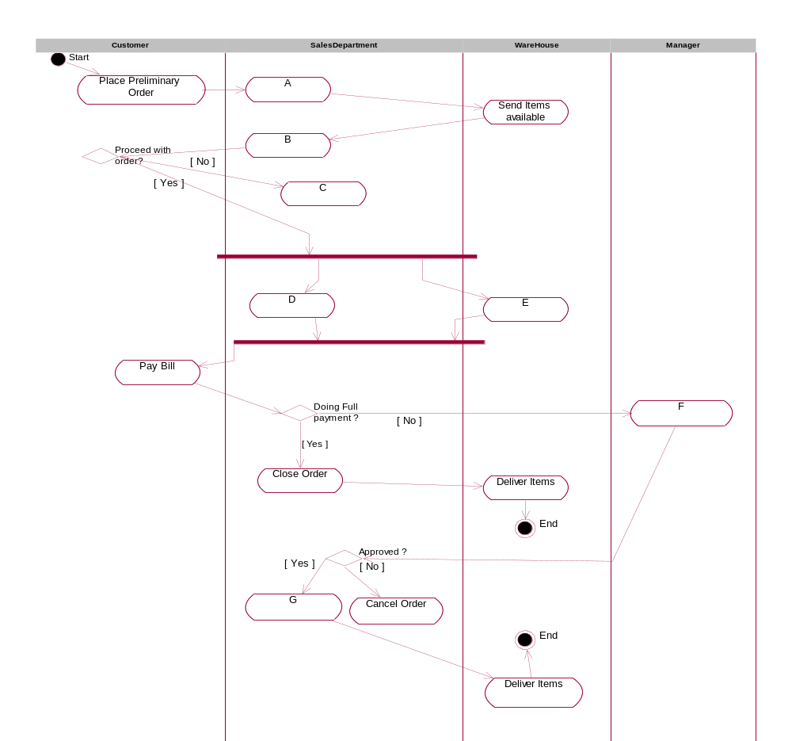
Activities:
- Approve Partial Payment
- Inform Customer
- Cancel Order
- Check Order
- Create Partially paid Order
- Bill Customer
- Prepare Items
(35% Marks)
 |  |  |  |  | ANSWER IN THIS BOX
A. | E.
B. | F.
C. | G.
D.

iv | vii
ii | i
iii | v
vi

(d) A student has found that the Object of class order for the above scenario undergoes state changes and the following state diagram was created. Identify the correct states and fill in the blanks.

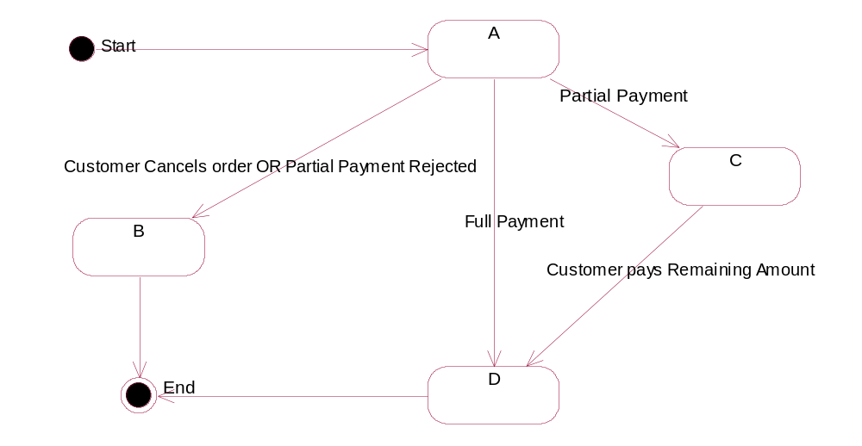
States:
- Closed ii Preliminary Order iii Partially Paid iv Cancelled
(20% Marks)
 |  |  |  |  | ANSWER IN THIS BOX
ii
iv
iii
I

4) |  |  | A class called Point contains a two argument constructor, a destructor which are public and private data members x and y.
- Define the class Point in C++. (Implementation of member functions are not required.)
(20% Marks)

ANSWER IN THIS BOX
class Point
{ private: int x,y;
public: Point(int x,int y);
~Point();
};
- Implement the two argument constructor for class Point in C++.
(15% Marks)
 |  |  |  |  | ANSWER IN THIS BOX
Point::Point(int a, int b)
{
x = a;
y = b;
}

For parts (c), (d) and (e), use the following description.
Create a class called Circle reusing the code written for Point class. A circle has another data member called radius(data type double) in addition to x and y, a no argument constructor which creates a circle object with all dimensions equal to one unit and a three argument constructor which creates a circle object with desired values for x, y and radius. It has another public method called Area to calculate the area of the circle.
Give due consideration to the access specifiers of the Point class.

- Define the class Circle. (Implementation of member functions are not required.)
(25% Marks)
 |  |  |  |  | ANSWER IN THIS BOX
class Circle : public Point
{
double radius;
public:
Circle ();
Circle (int a, int b, double r);
double Area();
};
(d) Implement the no argument constructor of class Circle in C++.
(10% Marks)
 |  |  |  |  | ANSWER IN THIS BOX
Circle :: Circle():
Point(1,1)
{
radius = 1;
}

(e) Implement the three argument constructor and the method Area in C++. The area of a circle can be obtained with the formula, Area=3.14159*radius*radius.
(30% Marks)
 |  |  |  |  | ANSWER IN THIS BOX
Circle :: Circle (int a, int b, double r) : Point (a,b)
{
radius = r;
}
double Circle :: Area()
{
return 3.14159*radius*radius;
}

 |  | *****

